**CHRISTMAS IN BRITAIN AND IN THE US**

<https://www.youtube.com/watch?v=v2W3QR9WXdA>

*Watch the video on Youtube, fill in the chart and answer the questions …*

|  |  |  |
| --- | --- | --- |
|  | Christmas in the UK | Christmas in the US |
| Letters to Santa |  |  |
| Hanging stockings |  |  |
| Food for Father Christmas |  |  |
| Christmas dessert |  |  |

1. 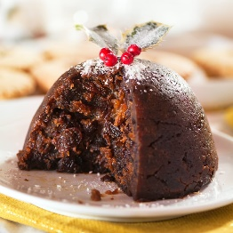What is a British Christmas cracker?
2. What do you find inside a Christmas cracker?
3. What do British people eat for the Christmas dinner?
4. Give 3 ingredients you can find in a Christmas pudding.
5. What is the Royal Christmas message?
6. When is Boxing Day? What do people do on Boxing Day?
7. 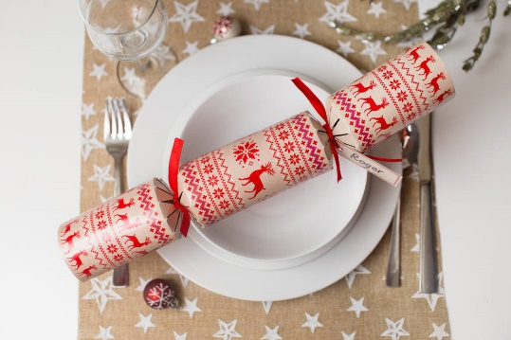What is the name given to the plays for kids based on fairytales you can see during the Christmas season?
8. What is the tradition with Christmas trees in the UK?
9. Give a familiar word which is a synonym of “*Christmas*”.

